# Sitemap

The website is based around the feed/homepage which is the landing place for the user when they visit the website. The first level elements are the core components of the site that can be accessed from the feed/homepage. The children of the second layer are easily accessed from their respective parents.

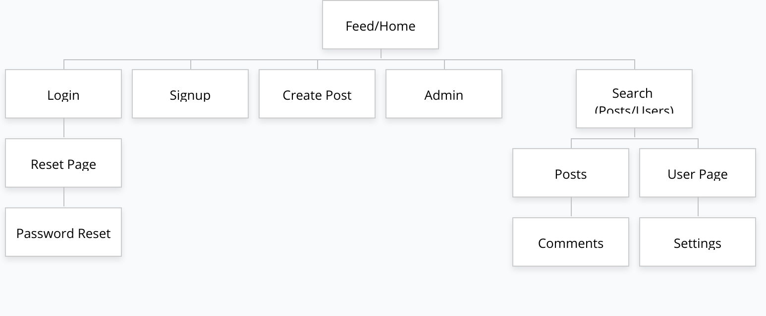

# Layout

## Feed/Homepage/Search

The feed and homepage are very similar, the feed is a specialized version of the homepage for a logged in user while the homepage will simply be the “trending” posts for some time period. The homepage will further be referred to as “trending” when the user is logged in.

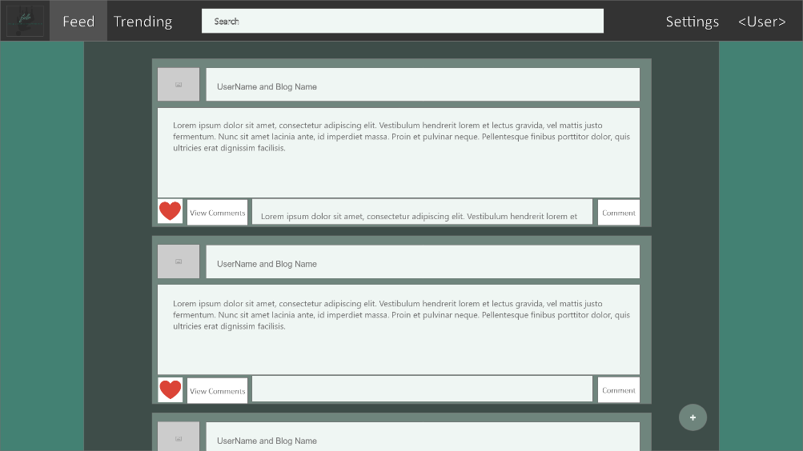

If the user would like to search for another user or a post, they can use the search bar in the middle of the page. This search bar will be available in all windows, but the example will be shown in the homepage.

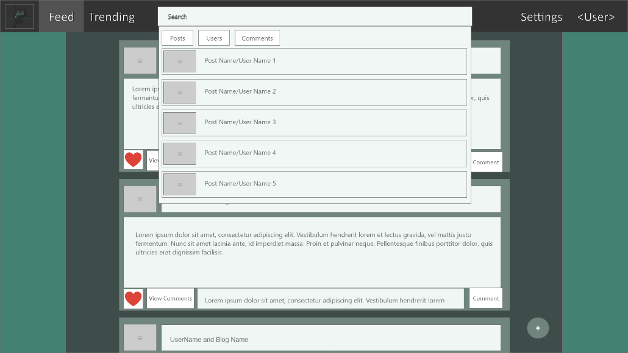

## Login/Create Account

The login and create account pages will be the first pages that the user visits after the feed. They will be accessible from the top right menu while the user is not logged in. Once the user logs in these menus will be replaced with a link to the settings and their own page.

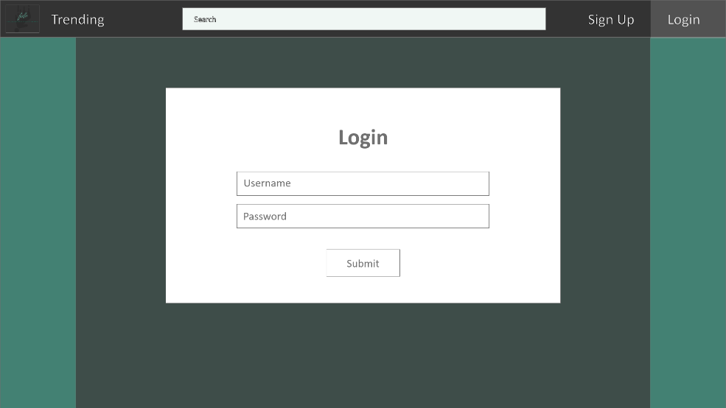

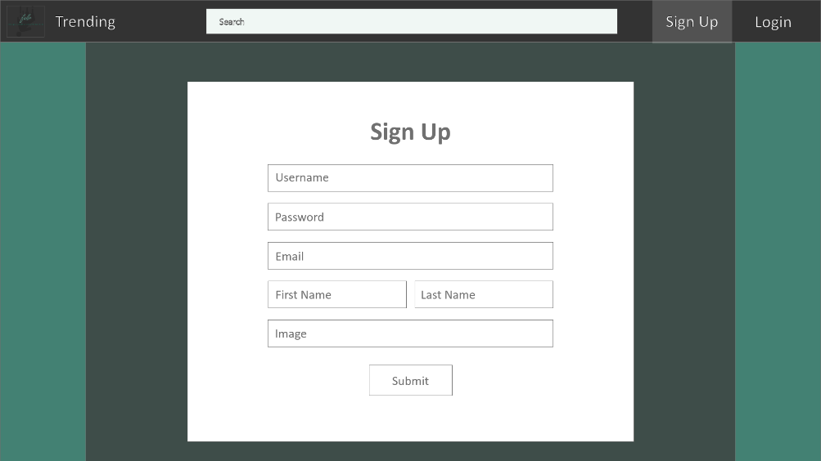

## Password Reset

Since many users forget their login information, they will be able to send the email associated with the account a password reset email. This can be done through the following form.

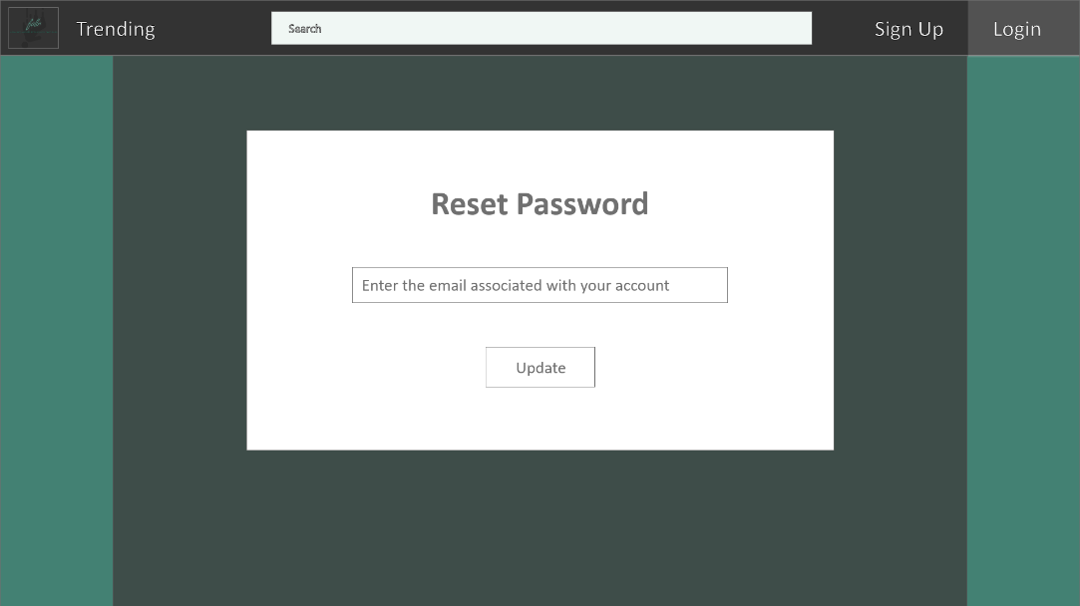

Once the user receives the email and clicks on the link, they will be redirected to the following page which requests the new password twice in order to ensure correctness.

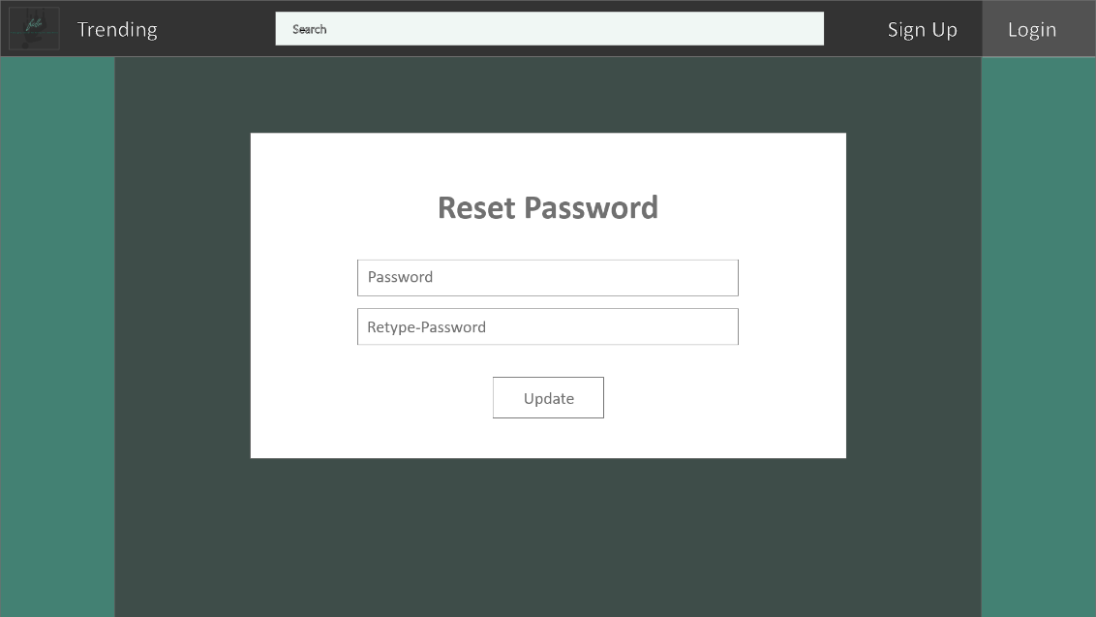

## Create Post

Once a user has logged in, they will be able to create posts. These posts can contain text and optionally an image for the post.

## Post Page/Comments

Once a post has been created it, along with all the comments and likes on the post, can be seen from the post page. This is the more unified version of the post which allows for a more complete view of the post than the feed or trending pages.

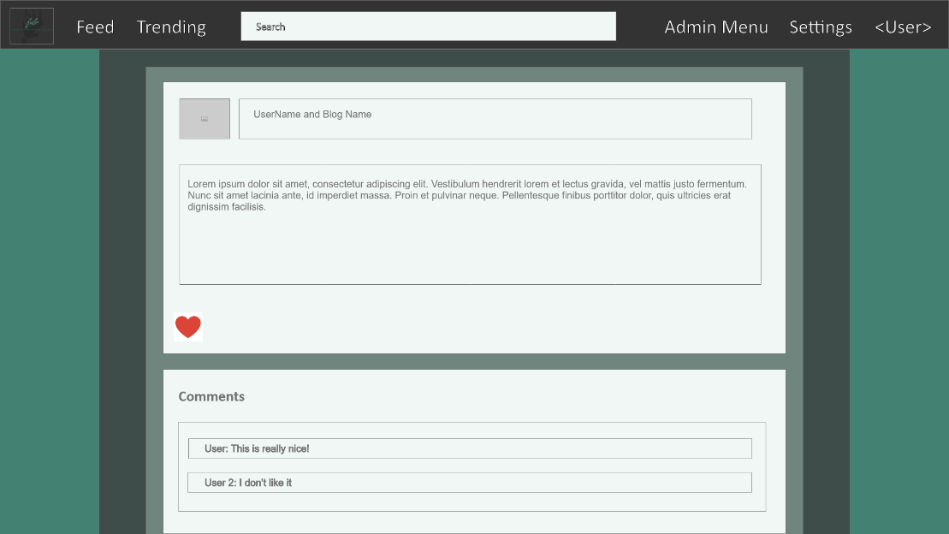

## User Page

Each user has a feed of the posts that they have made ordered from latest to earliest. This page will allow users to follow and view the followers of a user. The top of the page will feature an image of choice that the user can upload along with the name of the blog.

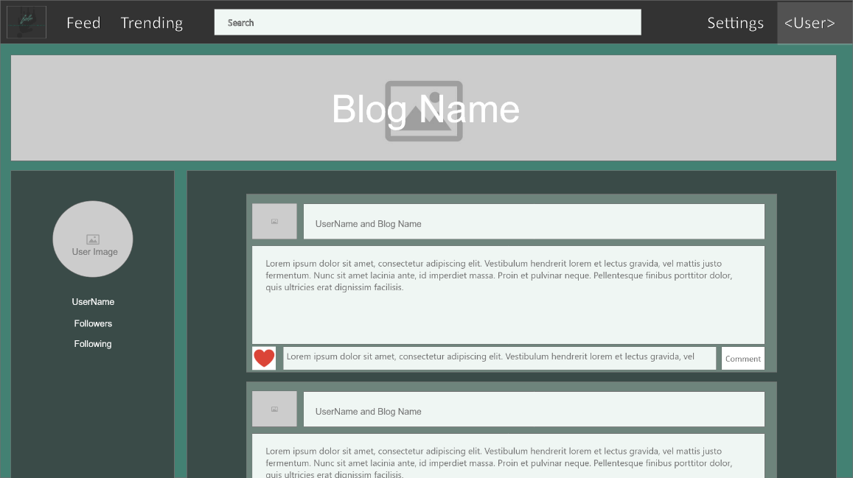

## Settings Page

For each user there will be a settings page which will allow users to update information about their profile. Each of the fields will be populated with the information about the user, except for the password which will simply be updated on change.

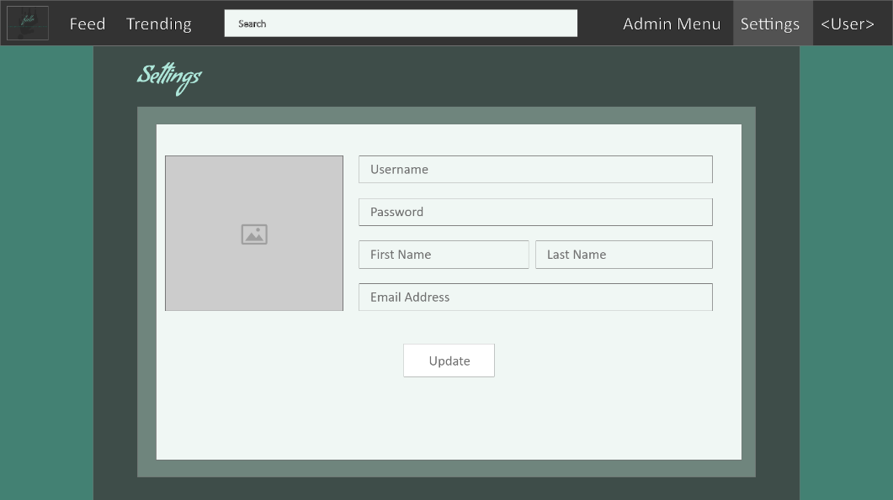

## Admin Page

The admin page is an additional functionality page for administrators of the site. It will not be visible to regular users. It allows an administrator to search for a user or enable/disable a user.

